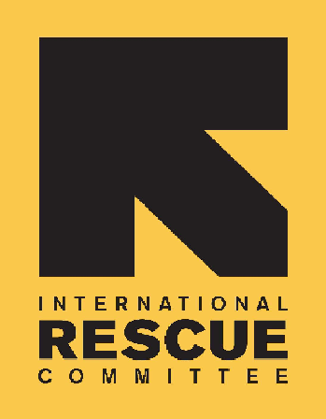
INTERNATIONAL RESCUE COMMITTEE, INC.
Sudan, Khartoum

BID NOTICE

The International Rescue Committee, Inc. (IRC) is a private international, nonsectarian, voluntary organization providing relief, protection and resettlement services for refugees and victims of oppression or violent conflict.

IRC is undertaking operations in humanitarian Aid in Khartoum and has a requirement for the following Provision of Medical & Life Insurance for 1 Year,

A framework agreement/Long term agreement/master Service agreement for Medical & Life Insurance for 1 Year.

Interested and suitably qualified suppliers may request complete tender information from the IRC office located at:

23 Nakheel Street, Building #279, Taif Area.
Khartoum, Sudan
Charbel Raad
011 828 3498

Offers to supply will not be accepted after 1 PM on the 12th November, 2020.

